Project Proposal
The Agile Team

Feb 25, 2013
SYST 699

Christina Gu
Jason Lee
Steve Smith
Contents
1 Introduction 3
2 Background & Problem 4
2.1 Problem Definition 4
2.2 Background 4
2.2.1 Agile Development Cycle 4
2.2.2 Waterfall Developmental Cycle 6
2.2.3 Spiral Development Cycle 6
2.2.4 V-Development Cycle 7
3 Literature Search 7
3.1 Area 1: Measuring Cost, Schedule, and Quality: 8
3.2 Area 2: Mapping Agile Methods to Traditional Methods: 8
3.3 Area 3: The Difficulties of Applying Agile Development: 8
4 Approach 9
4.1 Research and Information Gathering 9
4.2 Development of Evaluation Metrics 9
4.3 Analysis of Data 10
4.4 Presentation of Results 10
5 Management 11
5.1 Schedule and Resource Allocation, and WBS 11
5.2 Milestone Schedule 15

Introduction
Project Group 6 (Agile Team) is going to identify if there improvements with regards to cost schedule and documentation quality for system engineering products accompanying the V-model using Agile Software Development versus Traditional Software Development methodologies? The team is going to provide the sponsor with a clear understanding of whether or not Agile Software Development methodologies will have any positive contributions, in terms of cost, schedule and quality, when used within sponsor processes. Also we are going to identify what situations would be suitable for Agile Development.
The following items will be addressed in the written report and presentation:
- Description of how the systems engineering process is applied differently on an Agile development project versus the traditional development project.
- Characterization of the differences in the content and quality of systems engineering products when performing Agile development and traditional development.
- Quantification of cost and/or time savings if any on an Agile project of cost and/or time savings, if any, on an Agile project.
Our plan for vetting deliverables with the sponsor is submit a written copy of our report to the sponsor which will occur on the following date: April 26th, 2013. Any feedback provided will be incorporated, and the report reissued in its entirety.
Some of the initial Risks has been identified and are listed below:
- If our scope is too broad, then the timely completion of our report within the semester will not be possible.
- If sponsor data is not readily available, our scope will change.
- If the sponsor is not satisfied with results, then the project will not be completed.
- If data collected cannot be analyzed to perform proper comparisons, our results will be inconclusive.
The Mitigation strategy for the identified risks is as follows:
- Meet with sponsor and define restricted scope.
- Cannot be mitigated without changing scope. This item drives us to rapidly define scope with sponsor.
- Vet results with sponsor throughout the project for continuous interaction and communication on where the project is headed.
- Develop method to ensure collected data is usable and continuously seek usable data from the sponsor.

Background & Problem

Problem Definition
Project Group 6 (Agile Team) is trying to identify the differences in the systems engineering products that result from an Agile software development effort versus more traditional software development methods such as the Waterfall method. The Stakeholder, Boeing, is particularly interested in whether there are systems engineering quality, cost and/or schedule savings using an Agile software development process. The traditional systems engineering “V” processes and associated program milestones and systems engineering products should be considered when performing the comparison between traditional and Agile software development approaches. The traditional Waterfall approach as well as other traditional methods should be compared with the Agile approach.

Background
In this Section brief background information of Agile, Waterfall, Spiral, and the V Model are identified.

Agile Development Cycle
In Agile Software Development is Step-wise Development Scheme:
First Step - develop in small steps
Second Step - produce something useful in each step that can be presented to the customer
Third Step - consider Customer feedback in the following development steps
It emphasizes the following criteria:
-Individuals and interactions over processes and tools
-Working software over comprehensive documentation
-Customer collaboration over contract negotiation
-Responding to change over following a plan

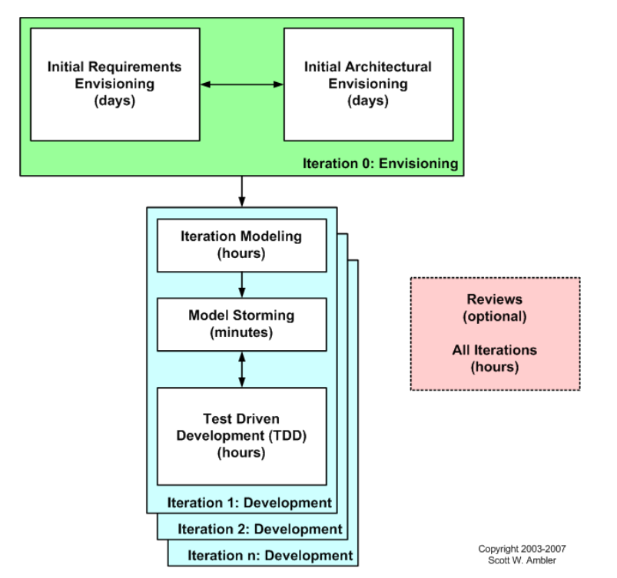
Agile Development Process follows the following general scheme:
- Identify the high level scope
- Identify initial requirement stack
- Identify an architectural vision
- Modeling is part of iteration plan effort
- Need to model enough to give good estimates
- Need to plan the work for the iteration
- Develop working software via test first approach
- Details captured in the form of executable specifications

Waterfall Developmental Cycle

Waterfall Development model was the initial software systems development approach. All of the requirements are known up-front. It follows the Philosophy: ‘What to do?’ before ‘How to do it?’ Waterfall development Cycle is still used in certain types of systems, with low complexity and systems that cannot evolve.
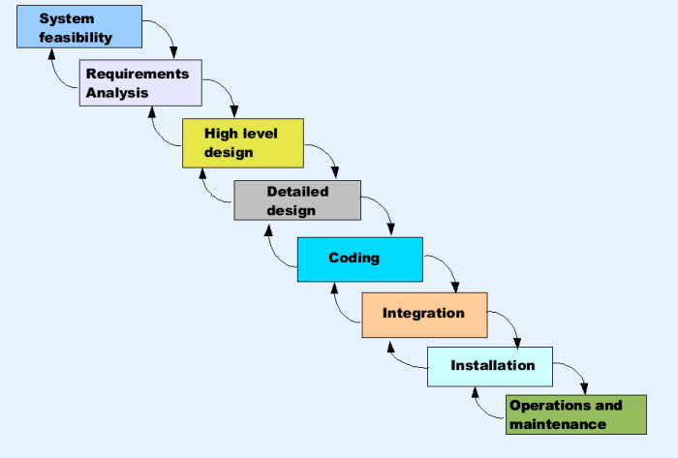
Figure 2: Waterfall Development Cycle
Some concerns that are identified in this Developmental cycle are listed below:
- Relationships between the early phases of the project to the end results are not illustrated
- Stakeholder involvement is not recognized beyond the initial requirements

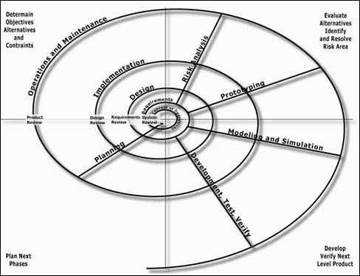
Spiral Development Cycle
The main emphasis of the Spiral Development Cycle is to mitigate the risk of software development. It does so by emphasizing the iteration between the form and function experimentally. It has been identified to work well with emerging properties and partial solutions of software, such as user interface, algorithms, or alternative sequences of events. This model can be easily used within phases of the V-development model to examine the feasibility of a concept and to derive a set of requirements. A similarity to Agile Development Cycle is the encouragement of iteration in the development process.
Figure 3: Spiral Development Cycle

V-Development Cycle
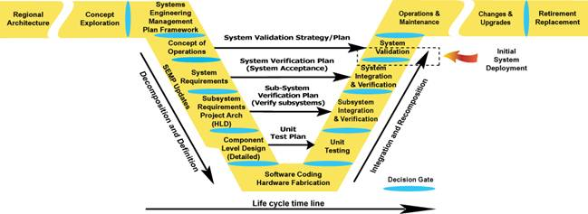
V-Development starts off with decomposing the system into the most basic form, and ends with integration to a whole.
Here are some of the key aspects of V-Development Cycle
- Illustrates the influence of the early phases of the project on the end of the project
- Emphasizes the planning, stakeholder involvement, validation of the requirements, as well as the validation of the product
- Illustrates planning, defining, performing integration, and verification. Emphasizes the need to begin verification planning at the time requirements are first defined
at every level.
Figure 4: V-Development Cycle
- Encourages the “Starting at the Finish Line” mindset, by looking at the validation of the product at the same time as developing the Concept of Operation, as well as the development of Verification Plans with the requirements at every level
- Illustrates “top down” definition and decomposition. A specification is written for it to be built as a key systems engineering activity. It shows a “bottoms up” building, integration and verification

Literature Search
The literature research for the Agile team has been focused mainly on three main areas. The first area is on existing methods for measuring cost, schedule, and quality for projects utilizing an Agile development cycle. The second area is on the mapping of Agile methods to traditional development methods. This research has turned up more literature on Agile development in comparison with the Waterfall model. The last area is on the difficulties of applying Agile development for systems that are developed with traditional methods.

Area 1: Measuring Cost, Schedule, and Quality:

The research efforts thus far have found that there are existing methods for measuring schedule within an Agile development environment that can be utilized to analyze a set of Boeing’s existing project data. Namely, burn-up charts and burn-down charts are applied at the end of every iteration of the Agile development cycle.
In terms of calculating cost savings for Agile projects, the AgileEVM (earned value management) method can be applied. The method comes from the traditional earned value management method for measuring the health and status of a project as it is ongoing. The AgileEVM is an adapted version of the traditional EVM methods for the way Agile development cycles work.
Quality is a much more difficult measurement to quantify. The existing research on this area is in the form of trade studies done on the use of Agile development versus a traditional development method. The comparisons are generally not mathematical but more in terms of how the process tightly integrates with the desired business goals of the project team.

Area 2: Mapping Agile Methods to Traditional Methods:

This area of the research dealt with existing methodology for mapping the processes associated with traditional development cycles, namely the waterfall model, to where they should fall within an Agile development method. Another part of the research literature covers measurement methods and how they apply in both development methods. This topic area is mainly academic rather than empirical in nature. However, the team can utilize the mappings to mock up a trade study using existing project data from Boeing. This must be done due to the lack of actual trade study data on the topic.

Area 3: The Difficulties of Applying Agile Development:

This area focuses on the issues that have been discovered in current research regarding the pros and cons of trying to apply Agile development in certain scenarios. The project problem was originally defined as utilizing cost, savings, and quality measurements to enable Boeing to convince their employees that Agile development will produce benefits for projects. However, it is important to realize that some parts of Agile, while conceptually works, have faults when applied in reality. One of the biggest faults is the scalability of Agile within large scale projects. The rigidity necessary to run a large scale project often does not work with the lack of rigid needs for requirements definition up front and lack of explicit long term goals associated with Agile development. The difficulty in applying Agile to such a project impacts how measurable cost, schedule, and quality would be for a comparison between two methods.

Approach
The Agile Team has developed a phased approach to compare Agile software development methodologies with traditional Systems Engineering software development methodologies. The phased approach is broken down into four sub sections. The four subsections are: Research and Information Gathering, Development of Evaluation Metrics, Analysis of Data, and Presentation of Results.
By progressing through the four phases, The Agile Team will perform and present a robust analysis comparing Agile software development to traditional software development methodologies. Each of the four phases of The Agile Team’s approach are detailed below. By defining a phased approach to the problem, The Agile Team will deliver a robust analysis supported by developed evaluation metrics.

Research and Information Gathering
Central to the success of The Agile Team’s endeavor, is researching and gathering information. The Agile Team anticipates the majority of collected information and research will fall under two primary classifications. The two primary classifications are academic centric and sponsor centric.
Academic Centric – Information pertaining to the comparison of Agile to traditional software development from a broad perspective
Sponsor Centric – Information directly from the sponsor
The majority of information collected is expected to fall into the academic centric category. Any information collected by the team which is not provided by the sponsor is anticipated to fall into the academic centric region. Information provided and obtained from the sponsor will be within the sponsor centric region and potentially be more useful for a comparison of software development methodologies for the sponsor’s specific organization.
Challenging to the data collection process will be finding information on similar projects. Projects are not typically performed multiple times using a philosophically different approach between attempts. Such a characteristic will primarily impact the development of the evaluation metrics.

Development of Evaluation Metrics
Comparison of Agile with traditional systems engineering in terms of cost, schedule and quality improvements is the goal of The Agile Team. An improvement in cost is quantifiable and defined as a project achieving the same result, but for a lower price. An improvement in schedule is quantifiable and defined as a project achieving the same result, but for a smaller investment in total hours spent on the project.
Contrary to the definitions of cost and schedule improvements, a definition for quality improvements must be derived. Part of the difficulty in defining quality is the subjective nature of the subject. The goal of The Agile Team will be to develop a quantifiable metric for identifying improvements in quality. Though subjectivity may potentially be involved in the development of the metric, the metric itself will be definitive and based upon logical analysis.
Involving the sponsor during the development of the quality evaluation metrics should help to maximize the effectiveness of the metric. The sponsor my already have some implicitly or explicitly defined standards of quality measurement in use. Involving the sponsor will enable The Agile Team to tailor the quality evaluation metrics specifically for the sponsor.

Analysis of Data
Hopefully, the development of robust evaluation metrics will speed the analysis of data. As mentioned previously, collecting information on similar projects using different development methodologies is not anticipated to be a simplistic task. Similarly, special care must be taken during the Analysis of Data phase to ensure improper weighting of results does not occur.
One of the steps taken to determine if any particular element of the analysis is distorting the results will be the performing of a sensitivity analysis. The primary goal of the sensitivity analysis will be to test the robustness of the results of the quality evaluation metrics in the presence of the uncertainty. The Agile Team hopes to highlight upon the sensitivity analysis during the presentation of the results to strongly support the quality of the findings.
Perhaps most impacted by the fact of lacking examples of the same project developed using different methodologies, will be the analysis of cost and schedule improvements. The analysis of the cost and schedule factors must be performed in such a way to be project independent.

Presentation of Results
Part of the driving reasons behind the exercise of comparing Agile software development to traditional software development is persuasive in nature. Clarity and brevity of The Agile Team’s presented results will be essential. Any potential stakeholders will need to be convinced the necessary steps were taken to insure The Agile Team’s results can be trusted. The processes used to determine results and in particular develop the quality evaluation metrics must be transparent and capable of being followed.
Should the methods and processes used be unclear in any way, the results will immediately be cast in a questionable lights. As the goal of The Agile Team is to deliver a definitive answer on the subject of the comparison of Agile and traditional software development, questionable results are highly undesirable. By following a clearly defined process of analysis, The Agile Team will deliver a definitive result.

Management

Schedule and Resource Allocation, and WBS
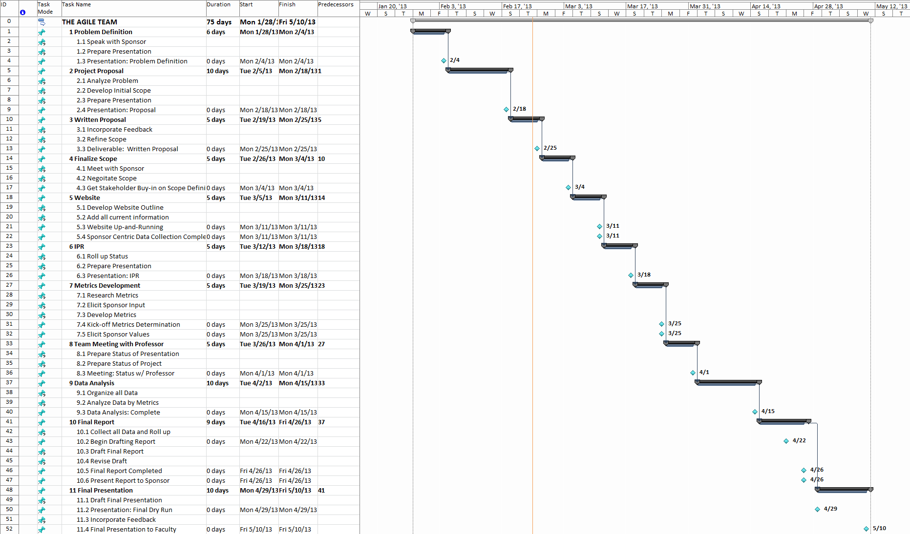

Table Name | Duration | Start | Finish | Predecessors | Resource Names
THE AGILE TEAM | 75 days | Mon 1/28/13 | Fri 5/10/13
Problem Definition | 6 days | Mon 1/28/13 | Mon 2/4/13 |  | Christina,Jason,Steve
Speak with Sponsor
Prepare Presentation
Presentation: Problem Definition | 0 days | Mon 2/4/13 | Mon 2/4/13
Project Proposal | 10 days | Tue 2/5/13 | Mon 2/18/13 | 1 | Christina,Jason,Steve
Analyze Problem
Develop Initial Scope
Prepare Presentation
Presentation: Proposal | 0 days | Mon 2/18/13 | Mon 2/18/13
Written Proposal | 5 days | Tue 2/19/13 | Mon 2/25/13 | 5 | Christina,Jason,Steve
Incorporate Feedback
Refine Scope
Deliverable: Written Proposal | 0 days | Mon 2/25/13 | Mon 2/25/13
Finalize Scope | 5 days | Tue 2/26/13 | Mon 3/4/13 | 10 | Christina,Jason,Steve
Meet with Sponsor
Negoitate Scope
Get Stakeholder Buy-in on Scope Definition | 0 days | Mon 3/4/13 | Mon 3/4/13
Website | 5 days | Tue 3/5/13 | Mon 3/11/13 | 14 | Christina,Jason,Steve
Develop Website Outline
Add all current information
Website Up-and-Running | 0 days | Mon 3/11/13 | Mon 3/11/13
Sponsor Centric Data Collection Completed | 0 days | Mon 3/11/13 | Mon 3/11/13
IPR | 5 days | Tue 3/12/13 | Mon 3/18/13 | 18 | Christina,Jason,Steve
Roll up Status
Prepare Presentation
Presentation: IPR | 0 days | Mon 3/18/13 | Mon 3/18/13
Metrics Development | 5 days | Tue 3/19/13 | Mon 3/25/13 | 23 | Christina,Jason,Steve
Research Metrics
Elicit Sponsor Input
Develop Metrics
Kick-off Metrics Determination | 0 days | Mon 3/25/13 | Mon 3/25/13
Elicit Sponsor Values | 0 days | Mon 3/25/13 | Mon 3/25/13
Team Meeting with Professor | 5 days | Tue 3/26/13 | Mon 4/1/13 | 27 | Christina,Jason,Steve
Prepare Status of Presentation
Prepare Status of Project
Meeting: Status w/ Professor | 0 days | Mon 4/1/13 | Mon 4/1/13
Data Analysis | 10 days | Tue 4/2/13 | Mon 4/15/13 | 33 | Christina,Jason,Steve
Organize all Data
Analyze Data by Metrics
Data Analysis: Complete | 0 days | Mon 4/15/13 | Mon 4/15/13
Final Report | 9 days | Tue 4/16/13 | Fri 4/26/13 | 37 | Christina,Jason,Steve
Collect all Data and Roll up
Begin Drafting Report | 0 days | Mon 4/22/13 | Mon 4/22/13
Draft Final Report
Revise Draft
Final Report Completed | 0 days | Fri 4/26/13 | Fri 4/26/13
Present Report to Sponsor | 0 days | Fri 4/26/13 | Fri 4/26/13
Final Presentation | 10 days | Mon 4/29/13 | Fri 5/10/13 | 41 | Christina,Jason,Steve
Draft Final Presentation
Presentation: Final Dry Run | 0 days | Mon 4/29/13 | Mon 4/29/13
Incorporate Feedback
Final Presentation to Faculty | 0 days | Fri 5/10/13 | Fri 5/10/13

Milestone Schedule
2/4 Presentations, Problem Definition
2/18 Proposal Team Presentation
2/25 Written Proposal
3/4 Finalized Scope Definition/Stakeholder Buy-in
3/11 Spring Break –partay Website Up and Running
Sponsor Centric Data Collection Completed
3/18 In Progress Review Presentation
3/25 Evaluation Metrics Determination Kick-off
Sponsor Input on Metrics (Value Elicitation)
4/1 Individual Team Meeting w/ instructor Status and draft of final presentation
4/8 Individual Team Meeting w/ instructor Status and draft of final presentation
4/15 Data Analysis Completed
4/22 Start Compiling Final Report
4/26 Final Report Completed-Present Final Report to Sponsor
4/29 Dry run of final presentation
5/6 Dry run of final presentation Final report due
5/10 Final presentation to Faculty

